WEEK 7

The Binomial Distribution
Many types of probability problems have only two outcomes or can be reduced to two outcomes. For example, when a coin is tossed, it can land heads or tails. When a baby is born, it will be either male or female. In a basketball game, a team either wins or loses. A true/false item can be answered in only two ways, true or false. Other situations can be reduced to two outcomes. For example, a medical treatment can be classified as effective or ineffective, depending on the results. A person can be classified as having normal or abnormal blood pressure, depending on the measure of the blood pressure gauge. A multiple-choice question, even though there are four or five answer choices, can be classified as correct or incorrect. Situations like these are called binomial experiments.
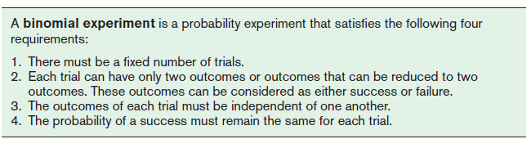
A binomial experiment and its results give rise to a special probability distribution called the binomial distribution.
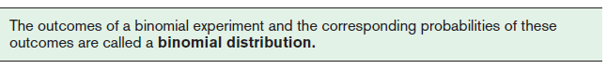
The probability of a success in a binomial experiment can be computed with this formula.

Binomial Probability Mass Function
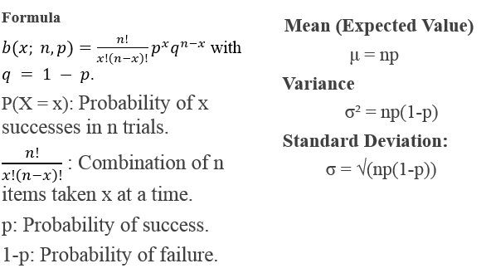
Example
A study found that 20% of software developers use a specific niche programming language for their personal projects. If a random sample of four software developers is selected, find these probabilities:
- Exactly 1 developer will use the niche language.
- At most 2 developers will use the niche language.
- At least 1 developer will use the niche language.
- d. Fewer than 2 developers will use the niche language.
Solution
Here, n=4 (number of trials) and p=0.20 (probability of success, i.e., a developer using the niche language). X∼B(4,0.20).

a. Exactly 1 developer will use the niche language.
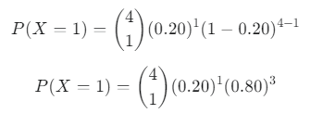
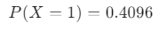
So, the probability that exactly 1 developer will use the niche language is 0.4096​
b. At most 2 developers will use the niche language.
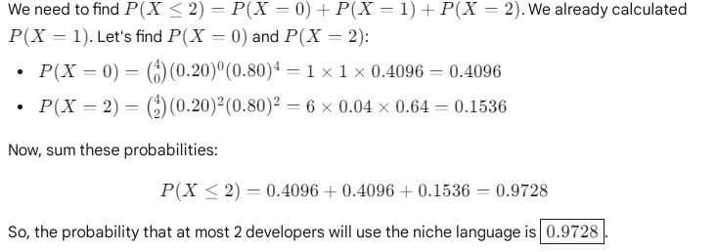
c. At least 1 developer will use the niche language.
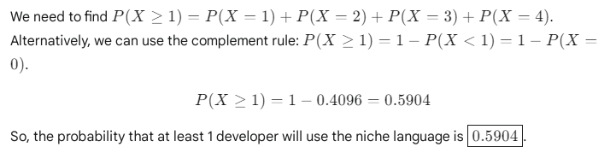

- Fewer than 2 developers will use the niche language.
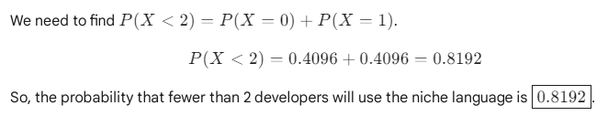
Practice Questions
Question 1
It is reported that 65% of software repositories on a popular platform use a specific open-source license. Choose 6 software repositories at random. Find the probability that:
- All use the specific open-source license.
- b. More than one-half use the specific open-source license.
- c. Exactly 3 use the specific open-source license.
Question 2
The percentage of software development teams that utilize agile methodologies is 75%. Choose 4 software development teams at random. Find the probability that:
a. None of the teams utilize agile methodologies.
b. More than 3 of the teams utilize agile methodologies.
c. Fewer than 2 of the teams utilize agile methodologies.
d. Fewer than 3 people will agree with that statement.
Mean,Variance and standard deviation

Question 1
If 80% of the applicants are able to pass a driver’s proficiency road test, find the mean, variance, and standard deviation of the number of people who pass the test in a sample of 300
Question 2
A large software company has 250 servers. Historically, there is a 0.5% chance that any given server will experience a critical failure during a typical week. Find the mean, variance, and standard deviation of the number of servers that will experience a critical failure in a week.

